|  |  |
| --- | --- |
| NAME | Mohamed Abdullah M |
| TEAM ID | PNT2022TMID37442 |
| PROJECT TITLE | **IoT Based Safety Gadget for Child Safety Monitoring & Notification** |

**Connect Device to IBM Watson IoT Platform**

IBM Watson IoT Platform is a complete end-to-end solution for IoT needs. It integrates a bundled set of services to connect, capture, register, analyze, and archive your IoT devices and data.

For more information and documentation on IBM Watson IoT Platform please see the following - <https://www.ibm.com/support/knowledgecenter/en/SSQP8H/iot/kc_welcome.htm>

**This is part two of a two-part series.** This document is a simple, easy to follow process to connect a device to IBM Watson IoT Platform. It will go through connecting via an MQTT connection.

In part one, [see part 1 - Configure IBM Watson IoT Platform to Connect a Device,](https://ibm.box.com/s/h8ucsoe13pj4pmmgzy2jwywdwhmreucz) IBM Watson IoT Platform account was created and configured, a device type was created, and a device was added.

The process is:

1. Connect Device to IBM Watson IoT Platform using MQTT

1. Login to IBM Watson IoT Platform to Verify Connection

1. Example Device Configuration and Python Connection (Optional)

1. Connecting to Quickstart (Optional)

1. Example Device Configuration and Quickstart Connection (Optional)

1. Additional Information

# Connect Device to IBM Watson IoT Platform using MQTT

The main means to connect devices to IBM Watson IoT Platform is via MQTT. The device will need a MQTT client software to connect and publish events. To add MQTT capability to devices, IBM provides reference implementations

Please see the following. <https://github.com/mqtt/mqtt.github.io/wiki/libraries>

The device must satisfy the requirements for the connection to be able to publish an event. On the device add a username, and password/authentication token and connect. Use the registration information to connect the device and start receiving device data. Set up the device for MQTT messaging and authenticate by using the organization ID, device type, device ID, and authentication token that was created in part one of this series. How to setup a specific device will vary by device.

The following information is required when connecting your device

## URL

<orgid>.messaging.internetofthings.ibmcloud.com

where orgid is the ID of the IBM Watson IoT Platform organization

created in part one.

## Port

8883

This is a secure encrypted connection

**Device ID** d: <orgid>:<device type>:<device id>

where:

orgid in the ID of the IBM Watson IoT Platform organization

created in part one device type is the device type created in IBM Watson IoT

Platform in part one device id is the device created in IBM Watson IoT Platform in

part one

**Username** use-token-auth

Username is the same value for all devices - use-token-auth This tells IBM Watson IoT Platform to use the devices authentication token which is the password.

## Password

Authentication token

Password is the device’s unique authentication token that was generated when the device was created in part one.

**Event topic format**  iot-2/evt/<eventid>/fmt/<formatstring>

where: eventid specifies the event name that is shown in IBM Watson IoT

Platform formatstring is the format of the event, such as JSON.

## Message format

JSON

**Certificate (optional)** when you use secure MQTT messaging, newer client libraries

automatically trust the default certificate that is presented by IBM Watson IoT Platform service. If this is not the case for your client environment, you will need a full certificate chain and specify that in the connection.

Once connected you will see the device connected in IBM Watson IoT Platform and the device can send data.

# Login to IBM Watson IoT Platform to Verify Connection

Go to URL -<https://internetofthings.ibmcloud.com/>

Click Sign in

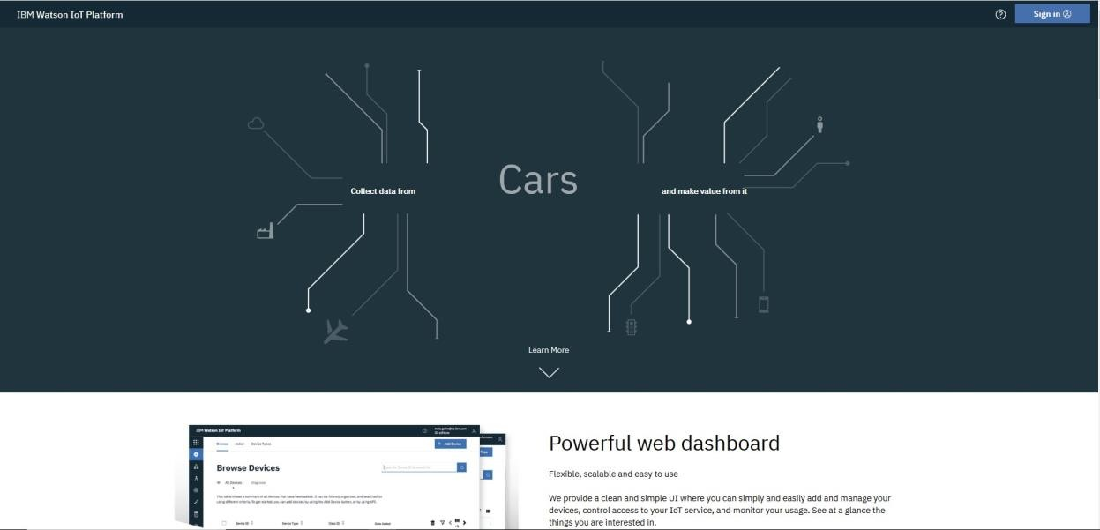

Enter an IBMid and click Continue

(Click Remember Me if you want)

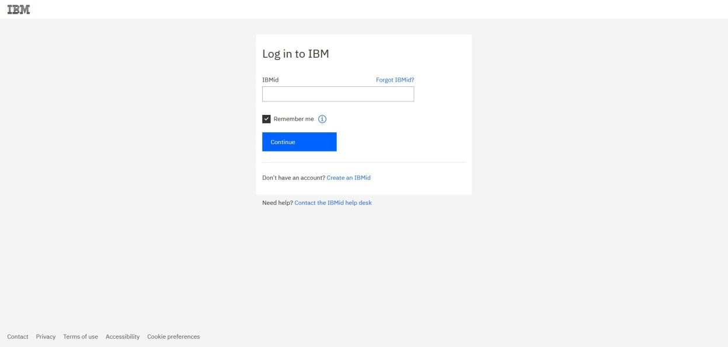

Enter the Password and click Login

(Click Remember Me if you want)

You are now logged into IBM Watson IoT Platform

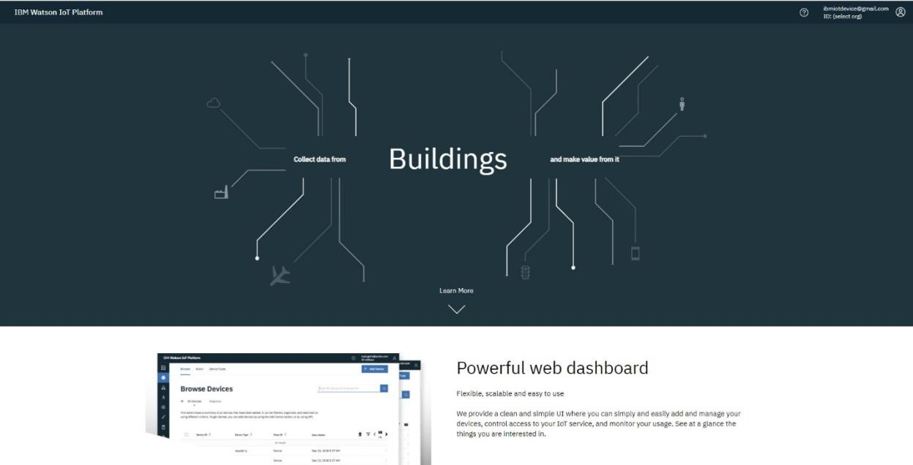

Click select org

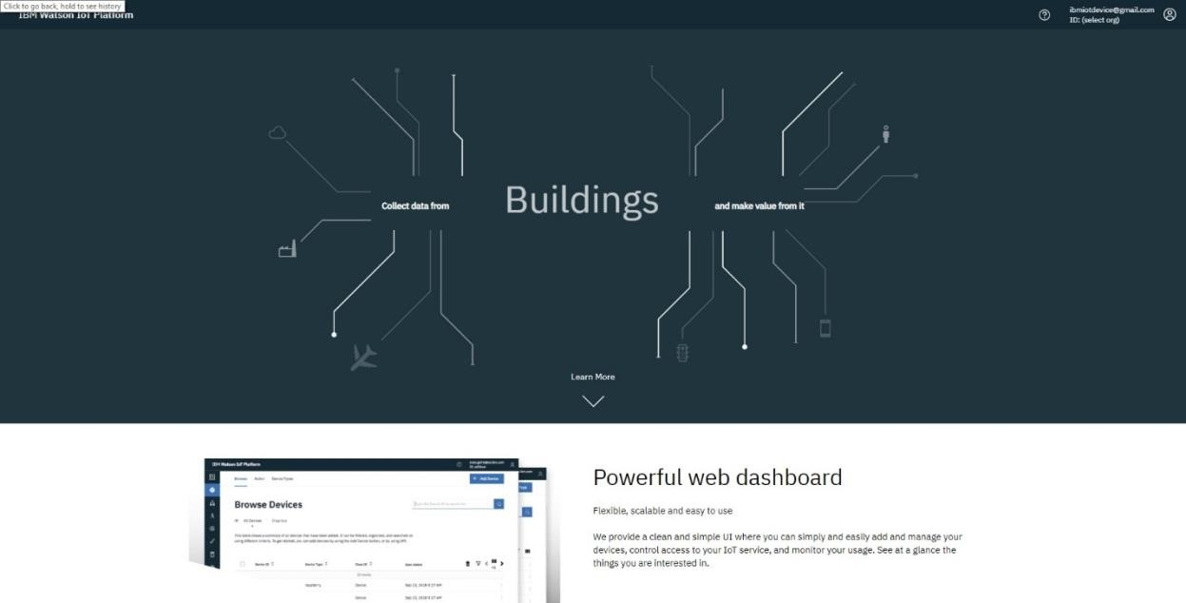

Select the org

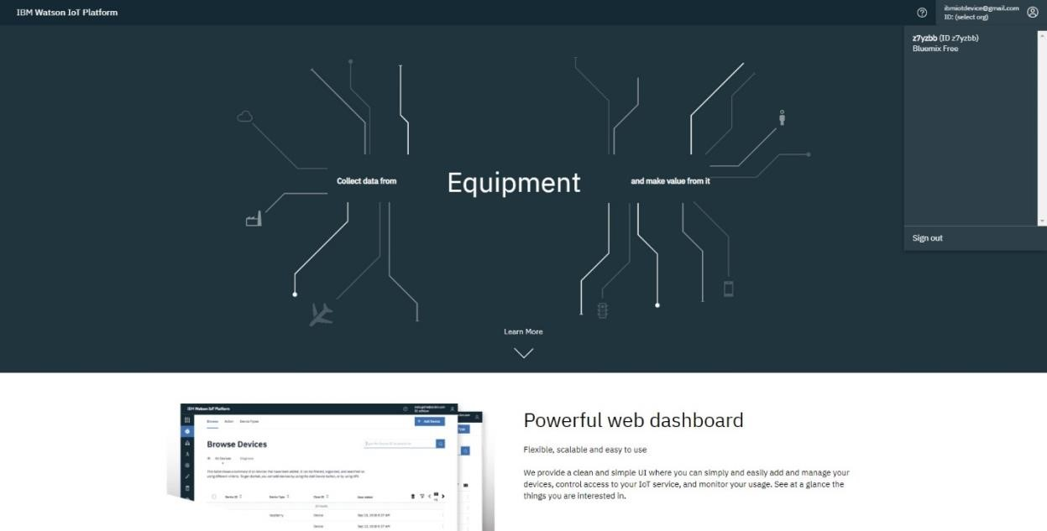

Click Devices option and see that the device is Connected.

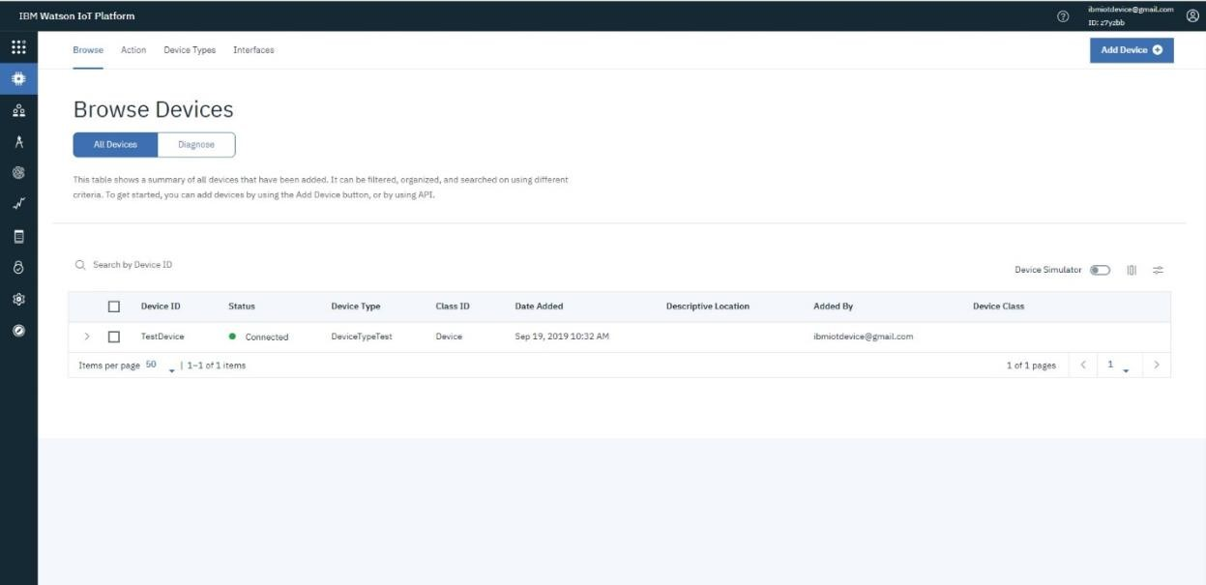

Click the device and Logs and see that the connection was made

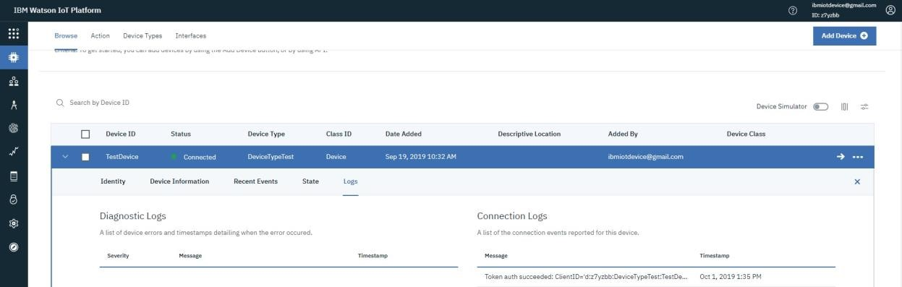

Click Recent Events and see the data that was sent from the device to IBM Watson IoT Platform

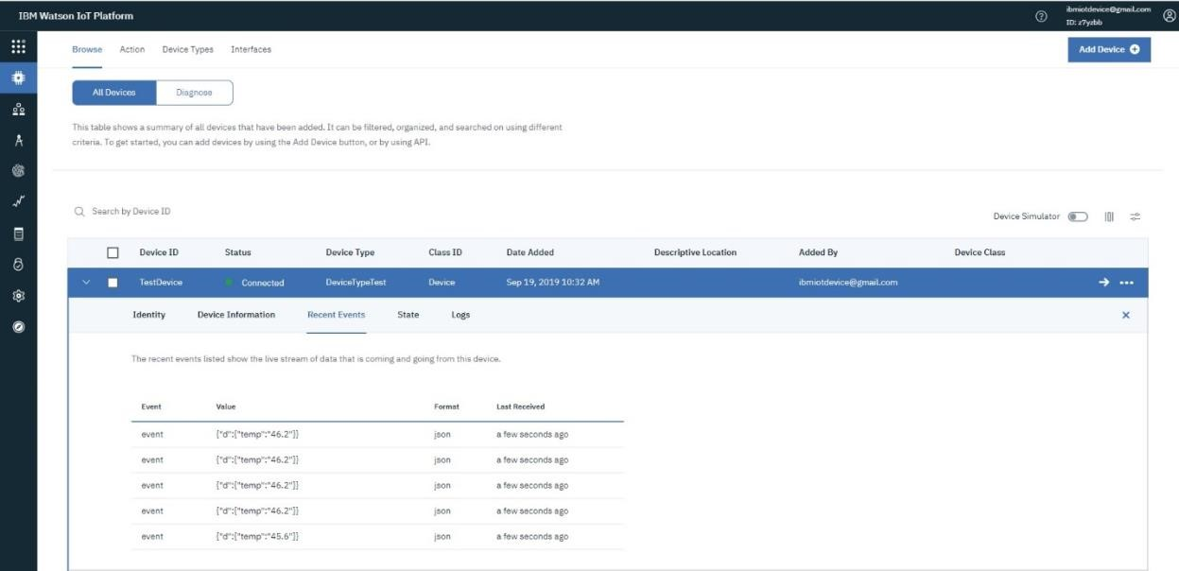

# Example Device Configuration and Python Connection (Optional)

## Test done with a Raspberry PI with Python

Install Python sudo apt-get install python-dev python-pip

Install the wiotp-sdk and psutil python modules sudo pip install wiotp-sdk psutil

Define environmental variables for the org, device type, device id, and authentication token. These values are the ones created and/or generated in IBM Watson IoT Platform in part one.

These variables correspond to the device parameters for the registered device

WIOTP_IDENTITY_ORGID WIOTP_IDENTITY_TYPEID

WIOTP_IDENTITY_DEVICEID

WIOTP_AUTH_TOKEN

Commands

export WIOTP_IDENTITY_ORGID=<orgid> export WIOTP_IDENTITY_TYPEID=<devicetype> export WIOTP_IDENTITY_DEVICEID=<deviceid>

export WIOTP_AUTH_TOKEN=<authtoken>

Run python python iotpsutil.py

# Connecting to Quickstart (Optional)

If you have issues connecting the device, you can use Quickstart to troubleshoot with a ‘simple’ connection. To make a quick connection of the device to IBM Watson IoT Platform you can use Quickstart. Connecting to Quickstart allows you to quickly verify your installation and connectivity to IBM Watson IoT Platform. It is not required to test via Quickstart. When you connect to the Quickstart service, authentication or registration is not required, and the orgId must be set to quickstart.

Quickstart does not require any IBM Watson IoT Platform configuration. It is a quick way to test connectivity from a device to IBM Watson IoT Platform in a unsecure connection.

Go to URL -<https://internetofthings.ibmcloud.com/>

Scroll down and click Launch Quickstart

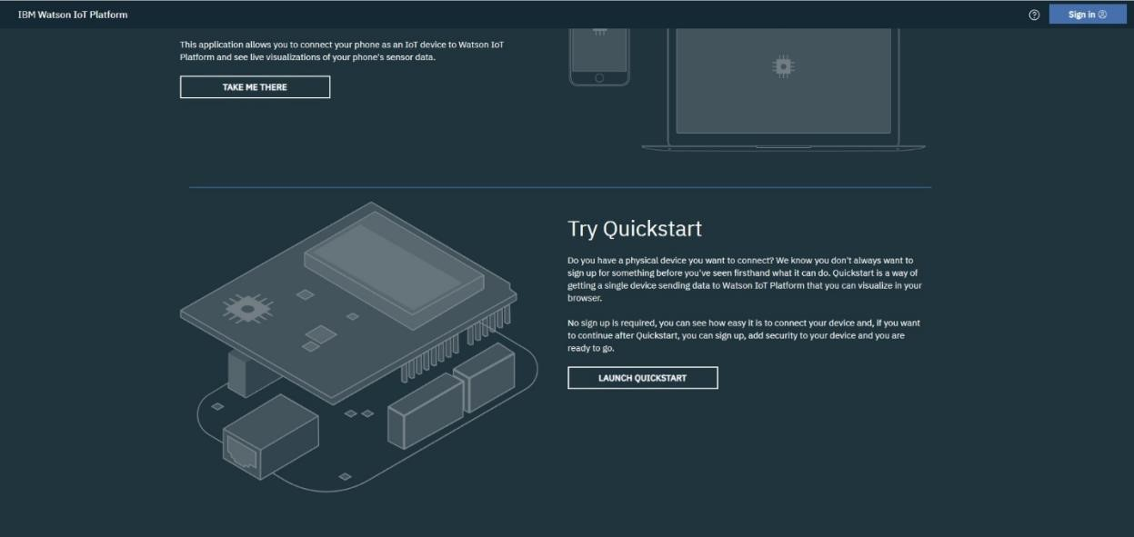

Click the box to accept the terms and enter the device id. Click Go

Device id will be a value from the device. See example below of a Raspberry Pi test.

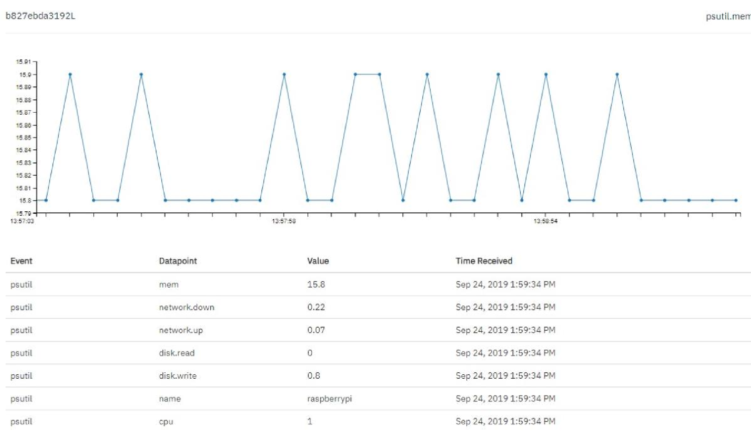

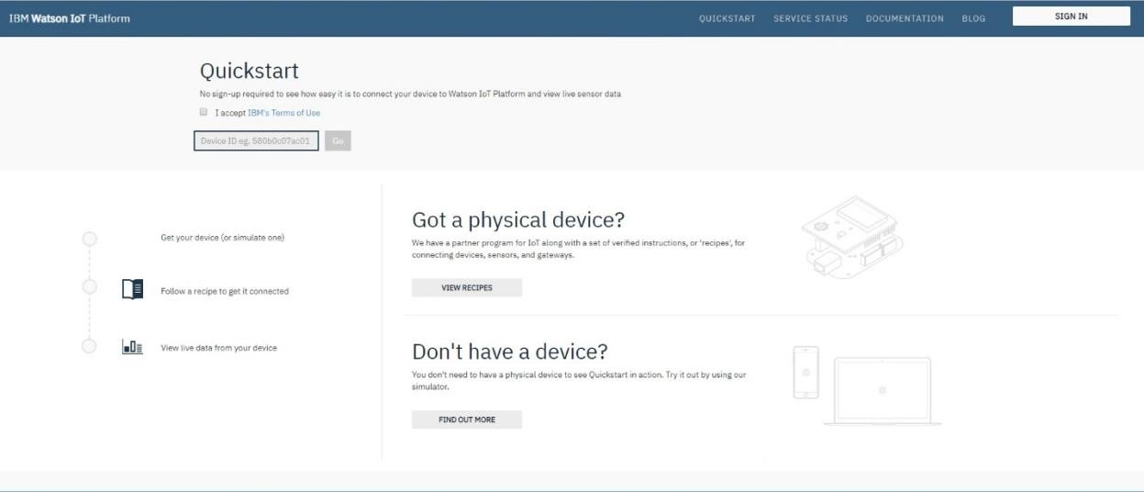

Data will start appearing for the device

# Example Device Configuration and Quickstart Connection (Optional)

## Test done with a Raspberry PI with Python

Install Python sudo apt-get install python-dev python-pip

Install the wiotp-sdk and psutil python modules sudo pip install wiotp-sdk psutil

Download the sample code from GitHub sudo apt-get update

sudo apt-get install python-dev python-pip

sudo pip install wiotp-sdk psutil

wget https://github.com/ibm-watson-iot/iot-python/archive/master.zip unzip master.zip

cd iot-python-master/samples/psutil/src

Connect to quickstart python iotpsutil.py --quickstart

The –quickstart command line argument will configure the device client to connect to quickstart using a generated deviceId based on the Pi’s MAC address.

Output

<DateTime Stamp> wiotp.sdk.device.client.DeviceClient INFO

Connected successfully: d:quickstart:sample-iotpsutil:b827ebda3192L Welcome to IBM Watson IoT Platform Quickstart, view a vizualization of live data from this device at the URL below:

<https://urldefense.proofpoint.com/v2/url?u=https-XXXX>

(Press Ctrl+C to disconnect)

Where XXXX is the rest of the specific URL

# Additional Information

* For more information and documentation on MQTT please see the following – [https://www.ibm.com/support/knowledgecenter/SSQP8H/iot/platform/referenc e/mqtt/index.html](https://www.ibm.com/support/knowledgecenter/SSQP8H/iot/platform/reference/mqtt/index.html)
* [https://developer.ibm.com/blogs/open-source-ibm-mqtt-the-messagingprotocol-for-iot/](https://developer.ibm.com/blogs/open-source-ibm-mqtt-the-messaging-protocol-for-iot/)

* For more information and documentation on MQTT connectivity please see the following -

[https://www.ibm.com/support/knowledgecenter/en/SSQP8H/iot/platform/devic es/mqtt.html](https://www.ibm.com/support/knowledgecenter/en/SSQP8H/iot/platform/devices/mqtt.html)

* If you’re not using MQTT, there are other ways to get data from devices to the Watson IoT Platform. Please see the IBM Watson IoT Platform Knowledge Center for information -

[https://www.ibm.com/support/knowledgecenter/en/SSQP8H/iot/platform/iotpla tform_task.html#iotplatform_task](https://www.ibm.com/support/knowledgecenter/en/SSQP8H/iot/platform/iotplatform_task.html#iotplatform_task)

* IBM Watson IoT Github repositories -<https://github.com/ibm-watson-iot/>